**OCAS: An Online Car Auctioning System to Aid Competency in Auctioning and Bidding of Cars**

**Bwalley Nicholas**

**122790**

**Submitted in partial fulfilment of the requirements of the Diploma of Business in Information Technology at Strathmore University**

**Strathmore Institute of Management and Technology**

**Strathmore University**

**Nairobi, Kenya**

**August 2020**

Declaration and Approval

I declare that this work has not been previously submitted and approved for the award of a diploma by this or any other University. To the best of my knowledge and belief, the research documentation contains no material previously published or written by another person except where due reference is made in the research documentation itself.

Student: Nicholas Bwalley

Sign: ________________________ Date: ___**28th August 2020**________

Supervisor: Joseph Mungai

Sign: ______**APPROVED**________________ Date: ___**28th August 2020**________

Abstract

Acquiring a car in the contemporary days has been a challenge for potential buyers caused by over-exaggerated car price set by the car-broker’s given the tender by the car owner to sell a car. This results to potential buyer’s incapability to buy a car due to their high expense. In addition, customers find it challenging for them to buy a car due to insufficient knowledge on where to buy a car in which is in good quality. This leads to time wastage for both the auctioneer and the potential buyer to get into contact, for them to conduct the auctioning process. In addition, auctioneers also find it challenging for them to sell their auction due to unavailability of the potential buyers as a result of their high expense. This later on results to high depreciation of the car which makes them to sell at a very low cost. The developed solution is an online web-based platform that enables registered clients auction their car as well as place a bid of an available cars, giving all integral details of the car. Clients can view the location of the car from the auctioneer in case he or she needs to physically see it and if declared the bid winner. The system is developed using the waterfall methodology where the phases are sequentially implemented.

Table of Contents

Declaration and Approval ii

Abstract iii

Table of Contents iv

List of Tables viii

List of Figures ix

List of Abbreviations x

Chapter: 1 Introduction 1

1.1 Background of Study 1

1.2 Problem Statement 2

1.3 General Objective 2

1.3.1 Specific Objectives 2

1.4 Justification 3

1.5 Scope and Limitations 3

Chapter: 2 Literature Review 4

2.1 Introduction 4

2.2 Auctioning Processes in Kenya 4

2.2.1 Challenges Faced by Auctioneers in Kenya 5

2.3 Related Works 5

2.3.1 E-Bay 5

2.3.2 Auto Auction Mall 6

2.3.3 Salvage Bid 7

2.4 Gaps of Existing Systems 8

2.5 Conceptual Framework 8

Chapter: 3 Methodology 10

3.1 Introduction 10

3.2 System Development Approach 10

3.2.1 Requirement Analysis 11

3.2.2 System Design 11

3.2.3 Implementation 11

3.2.4 Testing and Integration 12

3.2.5 System Deployment 12

3.2.6 System Maintenance 12

3.3 System Analysis 12

3.3.1 Use Case Diagrams 13

3.3.2 System Sequence Diagrams 13

3.3.3 Class Diagrams 13

3.3.4 Tools and Techniques to be Applied 13

3.3.5 Hypertext Mark-Up Language 13

3.3.6 Cascading Stylesheets 13

3.3.7 Hypertext Preprocessor 14

3.3.8 My Structured Query Language 14

3.4 System Design 14

3.4.1 Database Schema 14

3.4.2 Entity Relation Diagram 14

3.5 System Deliverables and Milestones 14

3.5.1 Clients 14

3.5.2 Administrator 15

Chapter: 4 System Analysis and Design 16

4.1 Introduction 16

4.2 Requirement Analysis 16

4.3 System Requirements 16

4.3.1 Functional Requirements 16

4.3.2 Non-Functional Requirements 17

4.4 System Design 18

4.4.1 Use Case Diagram 18

4.4.2 Sequence Diagram 20

4.4.3 System Sequence Diagram 21

4.4.4 Class Diagram 22

4.4.5 Entity Relationship Diagram 23

4.4.6 Database Schema 24

Chapter: 5 System Implementation and Testing 26

5.1 Introduction 26

5.2 Description of the Implementation Environment 26

5.2.1 Hardware Specifications 26

5.2.2 Software Specifications 27

5.3 Description of Testing 28

5.3.1 Testing Paradigm 28

5.3.2 Subset of Functional and Non Functional Requirements Tested 28

5.4 Testing Results 30

5.4.1 Authentication 30

5.4.2 Creating a User Record 31

5.4.3 Creating an Auction 32

5.4.4 Placing a Bid to an Auction 33

5.4.5 Availability 33

Chapter: 6 Conclusions, Recommendations and Future Works 35

6.1 Conclusions 35

6.2 Recommendations 35

6.3 Future Works 35

References 36

Appendix 38

List of Tables

Table 5.1 Hardware Specifications (Minimal and Recommended) 26

Table 5.2 Developer’s Computer Specifications 26

Table 5.3 User Interface Dependencies 27

Table 5.4 Authentication Test Results 30

Table 5.5 New User Creation Test Results 31

Table 5.6 Auction Creation Testing and Results 32

Table 5.7 Placing a Bid Testing and Results 33

List of Figures

Figure 2‑1 E-Bay 6

Figure 2‑2 Auto Auction Mall 7

Figure 2‑3 Salvage Bid 8

Figure 2‑4 Conceptual Framework 9

Figure 3‑1 Modified Waterfall Methodology 11

Figure 4‑1 Use Case Diagram 20

Figure 4‑2 Sequence Diagram 21

Figure 4‑3 System Sequence Diagram 22

Figure 4‑4 Class Diagram 23

Figure 4‑5 Entity Relationship Diagram 24

Figure 4‑6 Database Schema 25

List of Abbreviations

CRUD - Create Retrieve Update Delete

CSS - Cascading Style Sheet

DBMS - Database Management System

DFD - Data Flow Diagram

HTML - Hyper Text Markup Language

JS - JavaScript

MySQL - My Standard Query Language

OCAS - Online Car Auctioning System

PHP - Hypertext Preprocessor

USD - Use Case Diagram

# 

# Introduction

## Background of Study

Online auctions are among the most influential e-business applications. Their impact on trading for businesses, as well as consumers, is both remarkable and inevitable. There have been considerable efforts in setting up market places, but, with respects to market volume, online trading is still in its early stages (Rumpe, 2003).

Having the auction in a physical location limits bidders and sellers to a single location or forces them to travel with large pieces of industrial equipment either to or from the auction location. These travel needs add extra costs to attending the auction as well as more heavy lifting than necessary. For buyers, this could mean making the trip to a traditional auction and risking not even acquiring the desired piece. For sellers, it limits the market of buyers and requires moving the large equipment for sale with no guarantee that the desired buyer is at the auction. (Bidsuite, 2018)

 In recent years, the proliferation of the world wide web has led to an increase in the number of public auctions on the internet. One of the characteristics of online auctions is that a successful implementation requires a high volume of buyers and sellers at its website. Consequently, auction sites which have a high volume of traffic have an advantage over those in which the volume is limited. This results in even greater polarization of buyers and sellers towards a particular site. (Charu Aggarwal, 2009).

Auctions in the past decades were carried out in houses in which bids were made by the auctioneer delegating bids. This was limitation because it included the physical appearances of the bidder. This activity was unreliable because if the bidders fail to avail themselves the activity could not be carried out.

Traditional auctions take place in a physical location as a specified time with a time frame of a few hours, dependent on the length of bidding. To participate, bidders must attend the auction in person and, usually, all items for sale are present as well. Exchange of contracts usually happens immediately and all purchases are often made in cash. (Bidsuite, 2018).

Prevalently, both the auctioneer and the clients used to spend a lot of time and money for them conduct their auctioning process. The auctioneer used to transport the car for long distances to the auction location in order to auction the car and sometimes it was a challenge if there are no bidders to buy the product put to auction thereby causing a great loss to the auctioneer. The clients as well used to spend a lot of money in order to avail themselves in the auction locations. Sometimes the bidders and end up losing the bid due to high competition of the other opponents ready to buy the same product. In addition, the clients used to find it challenging to find the exact location on where the bidding is carried out and this could lead to the clients unavailing themselves.

## Problem Statement

Online auctions being the most influential e-business carried out worldwide. Despite the fact that considerable efforts have been set up in market places, trading online is laid in early stages. The astonishing concept of Internet market places is the conduction of online auctions. An online auction system holds online auctions for various products on a website. It creates a platform for buyers and sellers to come together and trade almost anything. (Muneeswaran Packiyaraj, 2016) Travelling by cars have become one of the major means of transport in which people use it not only for transport of goods but also to make a day to day living transporting of people and goods in different location. Major denoted challenges like Expense in acquiring transport facilities and set up locations is faced by auctioneers and bidders whereby the auctioneer must spend money in order to transport his car to the auction location, as well as high transport fares for the bidder’s to avail themselves to the auction location. In addition, auctioneers might avail their auction with high expectation that the auction is to be bought by the bidders but to no avail, the bidders might end up not bidding the product due to high price and low quality set by the auctioneer.

## General Objective

Developed a web application in which facilitates in an auctioneer posting his car and the clients place their bid in the limited duration of time given by the auctioneer, in which the system facilitates in determining the winner of the bid by viewing the highest price set by the bidder after the time duration expires.

### Specific Objectives

1. Analyzed the challenges faced by auctioneers and bidders in conducting the auctioning process.
2. Analyzed the current trends that have emerged and tried to solve problems that were formally experienced by the auctioneers and bidders.
3. Designed and developed a web-based application that facilitates registration of new clients in which a client can auction a car as well as participate in bidding an auctioned product.
4. Tested and implemented the OCAS system to ensure that data is validated before entry to the database and auctioning and bidding a car can also be done easily.

## Justification

Live auctions and online auctions are common auctioning carried out worldwide, but a lot of the auction companies are headed more online, with some companies now doing both live and online. One reason for going online vs. live auction is that all buyers have an equal playing field. Online auctions mainly break down and remove the physical limitations of live auctions such as geography, presence, time, space, and a smaller target audience. Auctions have evolved from live auctions to online auctions with the help of technology. (Institute, 2018)

The developed system facilitates in accomplishing auctioning of cars by creating a high level of buyer’s certainty on the type of cars they choose in their listed variety, in which they can place their bids effortlessly. The developed system also facilitates in helping bidders to find location of the product and they can easily place their bids on filling in the information required.

The system was designed in a way that an auctioneer can view in details of all the people who have placed a bid on his auction, but normal clients can only view the number of people who have placed the same bid and the current highest bid placed by one of the bidders at the moment. In addition, the auctioneer also issues a time of expiry in order to determine the winner of the bid placed.

## Scope and Limitations

The system allows registration of new users and a user can view all new bids and can become auctioneers when auctioning a bid. This online auction system only allows for the auctioning of cars. The system is limited to accommodate only citizens of Kenya located within the country. Only registered users can be allowed to place a bid and given authority to auction a car.

# Literature Review

## Introduction

In detailed explanations, this chapter explains how online auctions have been carried out previously and how bidding was performed, including all the limitations that the existing system used to face. In addition, illustrating the advantages and disadvantages of the developed system.

## Auctioning Processes in Kenya

Car auctioning is one of the online processes being carried out in presence of a web application. The process begins with an auctioneer posting the photo of his or her car to auction and giving details for example, the car mileage, the car transmission type and the car brand. The auctioneer issues a minimum bid in their own oblivion in which they would accept. (Business, 2012).

Car auctioning processes in some parts of Kenya is traditionally done, whereby the auctioneer issues a two weeks’ advance about conducting an auction of a certain product he wants to sell. He gives a brief description of the image about the product and giving integral details of how the product is set to operate and the duration it has been in use in case it is a second hand car. Thereafter, the auctioneer issues an early meeting and gets the details of the people who want to be part of the auctioning process.

Online auctioning is carried out in physical absence of bidding persons. This can only be achieved by a computer’s connection to the internet. The auctioning process in Kenya is carried out whereby an auctioneer transports his car to the bidding location, and wait for all the bidders registered previously to arrive in order to conduct the bidding process. Thereafter, one bidder sets to take the auction at a certain price whereby the other bidder needs to set a higher bid in order to knock the other bidder out. This process is done until one bidder sets the highest bid in which other bidders can’t place above and he is declared the winner of the bid. For example, if you place a bid on a car cost of Ksh100,000 and another bidder, places his bid on the same item at Ksh165,000 the person with the higher bid placed, knocks out the one with a lower bid. This bidding process continues until the duration of time expires in which the highest bidder is declared the winner of the item on bid. (Parsonburg, 2020).

### Challenges Faced by Auctioneers in Kenya

Prevalently, traditional auctioning process used to be carried out in a physical location within a very short time. To participate, bidders must register with the auctioneer and avail themselves in the place regardless of the distance from their homes. However, cash was the only means which was accepted for payment after being declared the winner of the bid and it was done immediately. This is a security challenge which might cause thuggery carrying bulk cash to an auction location in order to use it in bidding processes.

Time wastage is also a major challenge faced whereby an auctioneer does not find any bidder to bid his product for over several months maybe as a result of high set minimum price by the auctioneer which makes bidders not to buy the product, which may force the auctioneer to lower the price in order to get potential buyer to place the bid in that region.

Traditional auctions were being carried out in a substantial location with a time frame of a few hours, dependent on the length of bidding. To participate, bidders must attend the auction in person and, usually, all items for sale are present as well. Exchange of contracts usually happens immediately and all purchases are often made in cash. The time taken before a car is purchased were assemblage. The auctioneer used to take several days, weeks or months before he gets an appropriate bidder to meet his set requirements, which causes him to undergo a loss by price depreciation in order for the buyers to settle in making a decision to purchase the car in bid. (Bidsuite, 2018).

High cost of the car in bid is another confrontation faced by the bidders where they fail to take part in the bidding process due to the high standards set by the auctioneer and low quality of the car in auction which makes the bidders not register to take part in bidding that product.

## Related Works

This are systems advanced in order to conduct the auctioning process easily. In addition, these systems have been implemented and tested to the public in order to solve the problems in which live auctioneers face. The following systems include: E-bay, Auto Auction Mall, Salvage Bid.

### E-Bay

E-bay is an example of a similar online web-based application that facilitates auctioning of products including new and used products. It is a multinational e-commerce corporation based in San Jose, California founded by Pierre Omidyar in the year 1995. E-bay is used for facilitation of consumer to consumer and business to consumer through buying and selling a wide variety of goods worldwide hence full delivery of customer’s needs. Although it’s short-comings is that, you are required to figure out transportation means for the car if you have won the auctioned bid. 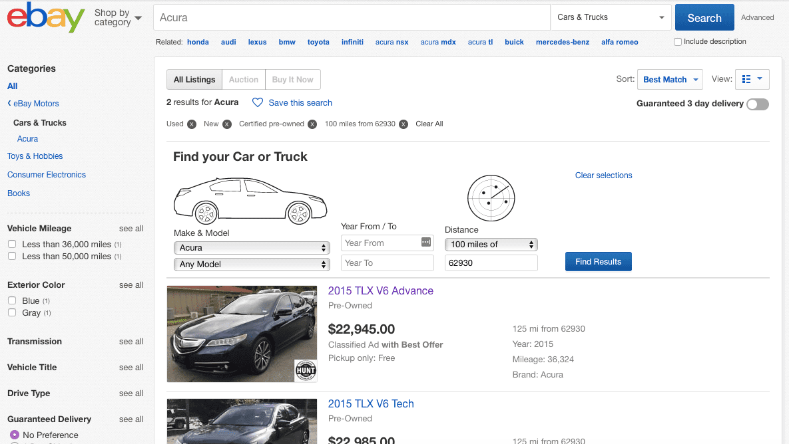

Figure ‑ E-Bay

### Auto Auction Mall

Auto Auction Mall is another similar example of an online auctioning which enables those potential buyers without a dealer's license the ability to bid on dealer-only auctions. These auctions often involve vehicles listed at wholesale prices, potentially guaranteeing you ultimate legitimacy and thus potential buyers save a lot of money. There are many varieties of cars available of all different makes and models auctioned.

Despite the fact that Auto Auction Mall facilitates linking a dealer and a buyer directly, after spending cash on a vehicle, you’ll be required to pay Auto Auction Mall a $299 fee for allowing you entry into the auctions on its website.

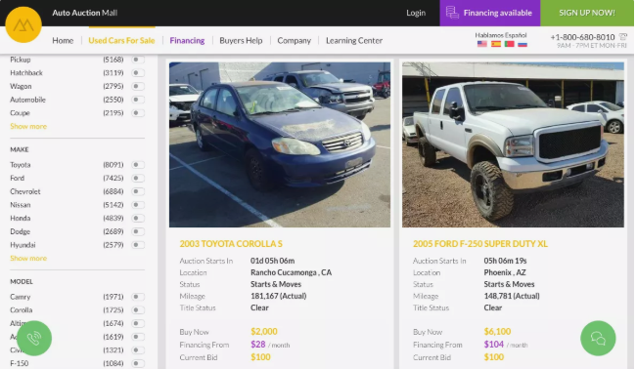

Figure ‑ Auto Auction Mall

### Salvage Bid

Salvage bid is an online car auctioning platform in which cars are auctioned at affordable prices. To get started on the platform, you'll need to register freely. Salvage Bid offers a free membership that allows you to bid in cases of preliminary bids. You also only get to purchase one vehicle on the free plan. Annually you are required to pay $200 to gain access to the Premium plan, which unlocks every auction and feature on the website.

Although Salvage bid facilitates in auctioning of cars at affordable prices, premium membership costs $200 annually, regardless of how often you use it. In addition, live auction bidding, a premium membership is paramount.

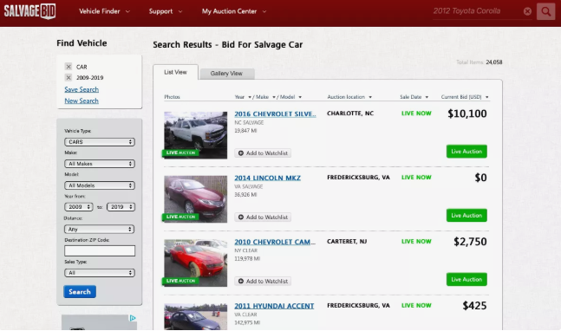

Figure ‑ Salvage Bid

## Gaps of Existing Systems

There are some systems already implemented and deployed in the market that serve different countries in which they facilitate auctioning of cars in an online platform although they lack a number of artefacts, which are going to be resolved with my developed system. There is need for a system to facilitate in notification of the bidders the current highest bid placed and the number of bidders who have taken part in bidding a certain product. There is need for a system that which not only a user can be able to place a bid but also become an auctioneers if he or she wants to sell a car. The developed OCAS system solves this problem through sending a notification of the bid status after a bid is currently sold to the highest bidder. In addition, the system provides the functionality whereby a potential bidder can be able to view how many bidders are currently placing the same bid and the current highest bid placed at the moment.

## Conceptual Framework

The figure 2.4 shows a disentangled explanation of how the OCAS system operates as well as how different operations are carried out. The entities involved the OCAS system are: users and administrators. The client logins to the system only if registered, in which they are inclined to a duet option of either auctioning of a car or taking part in bidding an auctioned car. If the client makes a decision to auction a car, he or she is requested to fill in details about the car model and make including other imperative details like the car mileage, transmission type etc. In addition, the auctioneer also specifies the time duration of when he wants to end the bidding process in order for the system to facilitate in determining the winner of the bid. If the clients make a decision to take part in a bidding a certain make of car, he is required to only enter his price and the system aids to fill all other details with the aid of the current session. An administrator is responsible for managing all users registered to the database, managing all auctions, and managing all bids currently in the system. He can be able to perform CRUD analysis to all the registered products in the database.

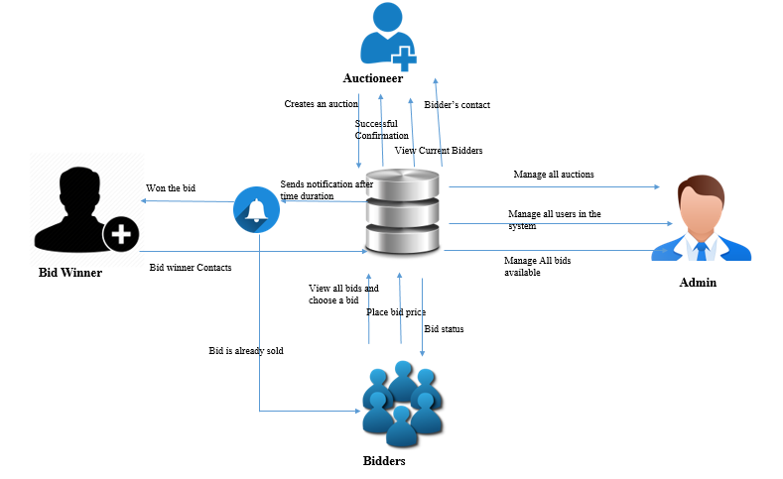

Figure ‑ Conceptual Framework

# Methodology

## Introduction

This chapter illustrates on the different techniques and methodologies that were used in developing of the OCAS system. The developed system is a web-based application which aids in creating a platform which helps in linking the bidders and the auctioneers to conduct auctioning process. The system methodology to be applied is the object-oriented analysis and design, whose main focus is on capturing the real-world objects in the current scenario that are of importance to the system. This methodology stresses more on data structure, as opposed to procedural structure. In this approach, objects are identified, and their relationships amongst each other, possible states that each object can be in, and finally how all objects collaborate with each other to achieve a broader system goal are identified.

## System Development Approach

The OCAS system was developed using the modified waterfall methodology, in which phases were sequentially implemented in software development. Waterfall model is a system development life cycle whereby the system was implemented sequentially which means one cycle completed followed by the other cycle. Using the waterfall model aids in ensuring data integrity and efficiency.

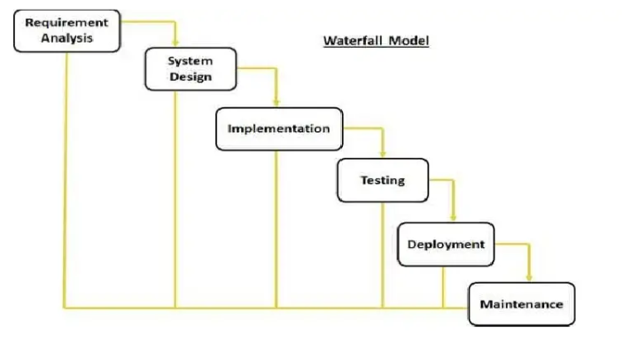

Figure ‑ Modified Waterfall Methodology

### Requirement Analysis

The requirements of the OCAS system are identified. User requirements is evident in the system, whereby a registered user can create a new auction which goes to the database as a live bid and all other registered users can be able to view the auction and place their bid except the auctioneer. Security being a nonfunctional requirement is also evident in the system whereby a user who has an auction, for him to access the auction history, he is prompted to enter his password in order to access all his auction made.

### System Design

A description of system architecture is explained in logical and physical designs. In logical design, the input like the user’s email and password are required by the user for the system to enable the user to perform certain functionality in the system like auctioning a car and placing a bid in an auctioned car. In the physical design, data inputs are verified in that after the user enters the correct credentials, he is authenticated to his user home page and can be allowed to make other operations.

### Implementation

Coding takes place in this phase. Information is taken in the previous stage by programmer’s in which they create a functional product. Code is implemented in small pieces in which integration is done at the end of this phase. Various functionalities which require intelligence are met. For example, a user who is an auctioneer cannot be able to place a bid of his own auction. Likewise, a person cannot be able to register a phone number which alphanumerical concatenations in between.

### Testing and Integration

At the end of the coding process, product testing is formally started. Testers sequentially find and report any problems. In case of a very serious issue, your project may need to return to phase one for reevaluation in order to make corrections for the testing and integration to be done again. Certain functionalities were tested in the system. For example, a user is entitled to only performing one operation in placing a bid of a certain car ID. In case a user tries to place a bid which he has already placed, the system sends a notification telling the user that he has already bided that product and redirects his to the bidding page again to choose another bid to place.

### System Deployment

After system testing, the system was taken to a small institute first in order to see its benefit to the few. Thereby after feedback from the user on how the system is, it is further inaugurated to function in all counties in Kenya.

### System Maintenance

A number of dilemmas might arise when released to the market or due to the major arise of the IT experts to conduct an upgrade to the system. Therefore, the system is therefore maintained by creating a newer version each and every time to curb this problem. Refactoring was also implemented whereby, restructuring the existing code was done to improve its performance without altering its external behavior.

## System Analysis

System analysis is the process of data collection, problem identification and recommendation of feasible suggestion of improving the functionality of the problem. The major objectives of system analysis are to find out what is being done, how to do, and how it can be improved. There are various system analysis diagrams, tools and techniques used in implementation of the developed system. They include:

### Use Case Diagrams

A use case diagram models the functionality of the system using actors present in the system and use cases implementation. Use case diagrams was used in order to show who are the actors in the system, their specific roles to perform in the system.

### System Sequence Diagrams

The system sequence diagram shows different scenarios of a use-case, generation of events by external actors. The system sequence diagram was used to elucidate the life line of each entity and the roles to take at specific times within the system.

### Class Diagrams

A class diagram was used to explain the class structure by showing their classes, attributes, and object relationship amongst others. The developed system illustrated different types of objects present in the system and how they relate with each other in order to facilitate in achievement of the objectives required by the buyer and the auctioneer of the product.

### Tools and Techniques to be Applied

The following tools and techniques are to be applied in the full development of the developed system. They include:

### Hypertext Mark-Up Language

HTML is a standard mark-up language designed in order to be displayed in the web browser. They include display of plain text, links, picture elements, sound and videos. Html are designed with special opening and closing tags. HTML as a front-end design was used in full development of the OCAS system, like user login page, home page and other pages.

### Cascading Stylesheets

CSS is a style sheet language designed for presentation of data written in html document in a satisfactory way. Unlike html which is used in creating the skeleton layout of the document, CSS is used for adding styles to the designed html document for example adding color, animation, responsive images to your web document.

### Hypertext Preprocessor

PHP is a server-side scripting language designed for interaction with the server. PHP is embedded with HTML as it is used to fetch data filled in the client side and fill into the database. Information filled by the user in the system was captured and posted to the database with aid of PHP.

### My Structured Query Language

MySQL is a relational database management system embedded with PHP in order to facilitate in storage of user’s information into a database. Information is written on the client-side using HTML and MySQL stores the information in the database.

## System Design

This phase elucidates the diagrams to be used in development of the OCAS system and the roles they play respectively.

### Database Schema

A database schema is structured diagrammatically to represent the relations in the database management system. A database schema was used to illustrate how different entity in the system relate to one another and the multiplicities in which all the entities inhibit.

### Entity Relation Diagram

An entity relational diagram illustrates entity stored sets in a database. It is used to sketch out the design of a database. In development of the OCAS system, the auctioneers and the clients cannot relate without the presence of the system. The auctioneers can directly relate with the database as well as the clients who can relate with the system in order to carry out their auctioning process.

## System Deliverables and Milestones

This entails what the developed system is expected to do, and the different tasks that the entities are to perform within the system.

### Clients

The clients can be able to take part in a duet option which include: Auctioning a car or taking part in bidding an auctioned car. If the client makes a decision to auction a car, he is required to fill all details about that car and it is put to auction in which other bidders can be able to view.

### Administrator

The system has solitary central administrator who is responsible for transaction management which involves registration of bidders, process communication, tracking and purchase handling.

# System Analysis and Design

## Introduction

This chapter focuses on the analysis and design that was used in development of the OCAS system. It explains in details how the system operates, giving the various analysis techniques used and finding the problem, finding the system’s general and specific designs and a theoretic representation of how the solution is implemented.

## Requirement Analysis

This stage focuses on the analysis techniques that were performed in order to meet the needs and conditions of the users. The requirement analysis technique which is used in development of the OCAS system is observation whereby the analyst generally observes how the current system operates and identifies the enigma experienced in the current system, thereby developing a methodical procedure of how to solve this dilemma.

## System Requirements

This are the systems configuration requirements requisite in order for a hardware or software to run efficiently and smoothly.

### Functional Requirements

#### Universal Login

A universal login is usable for already registered users in the system in which they are prompted to enter their username and user account password. The user and the admin can login using the same login platform but when he enters the username and password, the system determines which role is the user and redirects his to him homepage depending on his user type. If the user is an admin, the user is redirected to the admin’s dashboard. If the user is a normal user, he is thereby redirected to his user homepage.

#### Data Accessibility

The OCAS system is available and accesses in the country with the aid of internet services, in order for potential buyers to access all available bids in which they can take part in auctioning.

#### Data Integrity

The OCAS system aids in providing accuracy of data in that when a user enters incorrect username and correct password or vice-versa, and error message is displayed showing that the details are incorrect. Likewise, when a user successfully authenticates himself to the system, and goes to update his profile. After updating his details, the system inherits the new credentials and the user can use the new credentials in order to login to the system again, otherwise an error message is resulted.

#### System Security

System Security is met whereby when a user successfully logs in to his user homepage, and the page is standby for 10minutes, the session is set to expire and redirects the user to login again in order to access his homepage again. Therefore, security is met here because maybe the user forgets to logout, the session timeout automatically logs him out of the system and he is prompted to re-enter his credentials to access his user homepage again. System security is also met whereby when a user has an auction he has posted, for him to be able to access the auction, he is prompted to enter his password only for him to be able to access all his auctions history.

In addition, when the user logs out of the system, the system clears all session and when the user tries to press the back button of the browser or retype the URL, he is still redirected to the login page.

#### History Provision

OCAS system aids in providing history of all the auctions in which an auctioneer has posted to the database. An auctioneer can be able to make modifications and update new details about the car as well as he can be able to view all the bids he has placed on certain car ID’s.

### Non-Functional Requirements

#### Performance

In the system homepage when the user accesses the webpage, the page takes less than 4 seconds to load. Before redirecting the user to the homepage, a welcome message is displayed then redirects him to his homepage. The system is available for 24 hours 365 days in a year with scheduled exception and pre notified system maintenance downtime if needed.

#### Interoperability

The system works in different operating systems as from windows 7 onwards to windows 10 and all Linux versions (most preferably in Ubuntu version).

#### Portability

The web-based application is designed in such a way that it is responsive to big devices and smaller devices like it is portable in Laptops, desktops, tablets and mobile phones of different sizes.

#### Reliability

The system software, hardware and software, satisfactorily performs the task designed for within the specified period of time and environment in which it was designed to operate.

## System Design

This phase focuses on the system designs tools and techniques that were used with diagrammatic illustrations, relationships and entity descriptions.

### Use Case Diagram

A use case diagram is a representation of user’s interaction with the system, including all the actor’s roles in the system and entities included in the system. The system has two actors namely: the auctioneer (seller) and the bidder (buyer). OCAS system allows the clients to register, in which they are entitled to a duet option either to auction a car or take part in auctioning an auctioned car. If the user makes a choice to auction a car, he inputs all the integral details of the car, and set a duration of expiry of the auction in which the bid winner is declared immediately the auction expires. In case a user makes a decision to take part in auctioning a car, he is redirected to all current live bids and he makes a choice to bid either product.

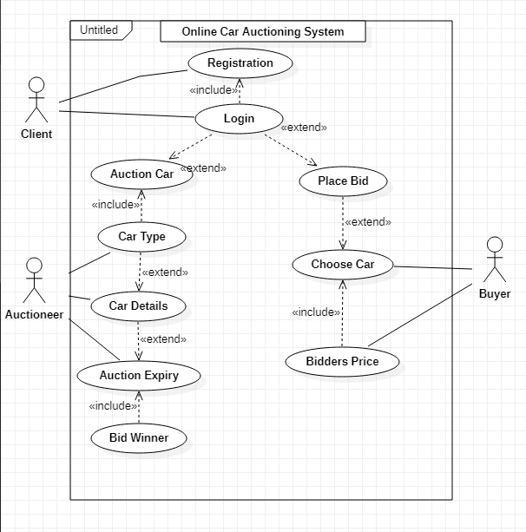

Figure ‑ Use Case Diagram

### Sequence Diagram

A sequence diagram is used to illustrate interactions between parts within a system to carry out a specified task. In relation with the OCAS system, the entities incorporated are as follows: the bidder, the auctioneer, the administrator and the auction database. The auctioneer having the major role in the system, who lists an auction and specifies the duration for expiry in which the information is sent to the auction database, a verification is sent to the auctioneer for a successfully done transaction. The bidder on the other end searches for available auction in which he makes a choice of the car he wants to participate in bidding that car. A successful confirmation is sent to the user when all legal conditions are met, otherwise an error message is sent to the user. After the bid expiry the bid becomes unavailable as a live bid and system facilitates in determining the highest bidder to be the bid winner.

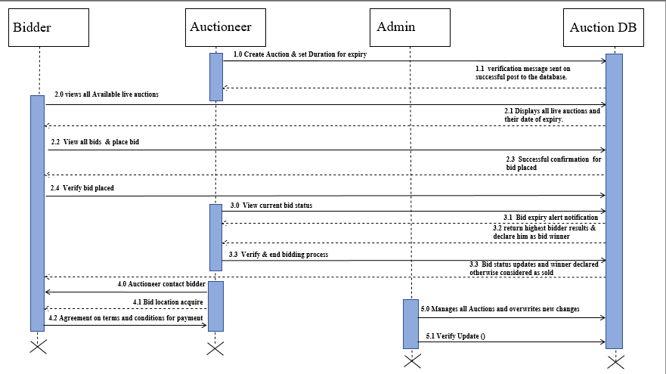

Figure ‑ Sequence Diagram

### System Sequence Diagram

A system sequence diagram is used to illustrate the relationship and interaction between the external entities of the system and the main system which facilitates main interaction.

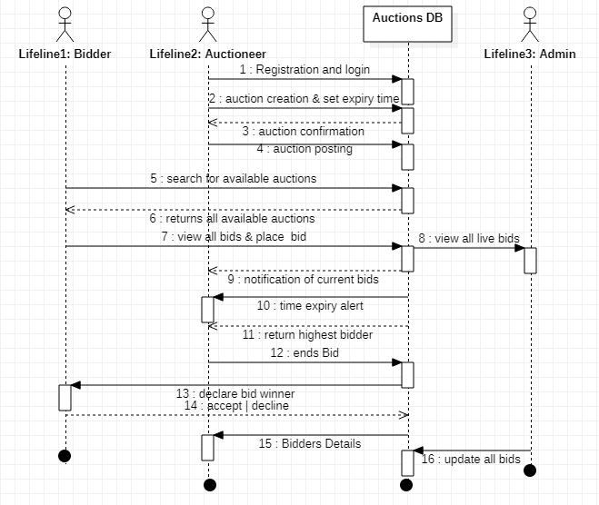

Figure ‑ System Sequence Diagram

### Class Diagram

A class diagram is a static structure diagram describes the system’s structure showing its classes their operation and attributes and relationship among other objects. In relation with the OCAS system, the attributes involved in the system are the auctioneers, the bidders, the admin, and the products.

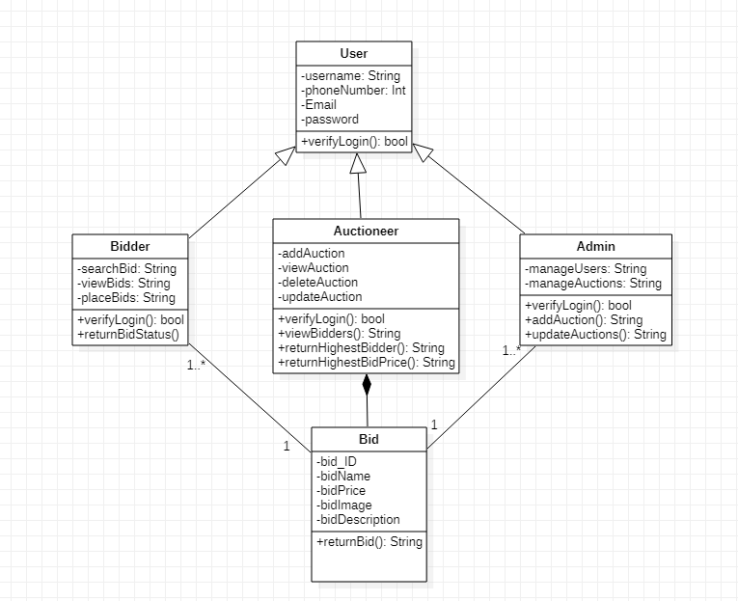

Figure ‑ Class Diagram

### Entity Relationship Diagram

An ERD show the relationship of entities set stored in the database. Each entity is enticed to an attribute showing relationships between each other within the system.

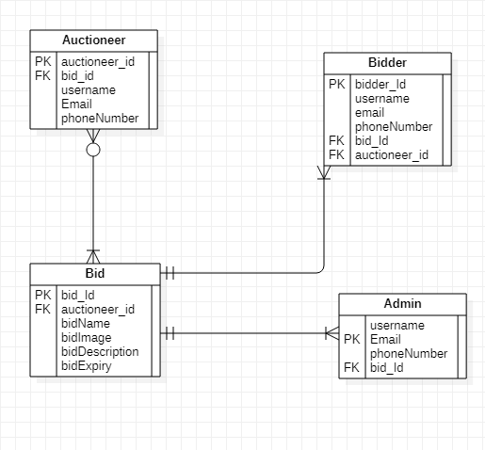

Figure ‑ Entity Relationship Diagram

### Database Schema

A database schema is a structural delineation of the entire database with all the defined relations involved in the system. The OCAS system has four relations which include: the administrator, the bidders, the products and the orders.

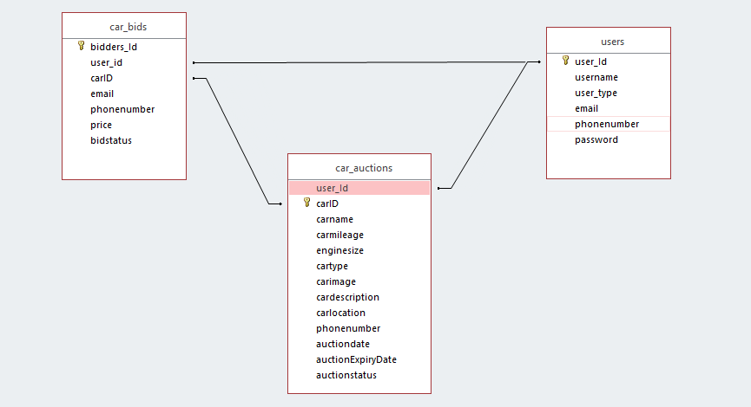

Figure ‑ Database Schema

# System Implementation and Testing

## Introduction

This chapter focuses on how the system development was done, the physical design, hardware specifications, software specifications and the system dependency. In addition, the chapter explains how system was carried out in order to meet high standards.

## Description of the Implementation Environment

This section explains in precisely on the systems hardware and software specifications required for the system to fully and functionally operating.

### Hardware Specifications

Table 5.1 below, shows an explanation of how the system’s minimal and recommended requirements to aid in running the online car auctioning system.

Table 5.1 Hardware Specifications (Minimal and Recommended)

|  |  |  |
| --- | --- | --- |
| **Item** | **Minimal Specifications**  **(Both the Web and The Database Server)** | **Recommended Specifications (Both the Web and Database Server)** |
| **Processor** | 2 x 1.6GHZ CPU | 4 x 1.6GHZ CPU |
| **RAM** | 2GB | 4GB |
| **Hard-Disk Storage** | At least 40 GB free space is the most recommended | At least 40 GB free space is the most recommended |

The table 5.2 below, is used to show the hardware specifications in development of the Online Car Auctioning System.

Table . Developer’s Computer Specifications

|  |  |
| --- | --- |
| **Item** | **Specifications** |
| **Processor** | 3.80GHZ |
| **RAM** | 8GB RAM |
| **Hard-Disk Storage** | 500GB SSD |

The developer’s computer meets all the minimum recommended specifications in order to develop and test the system.

### Software Specifications

The system was implemented using the LAMP (Linux, Apache, MySQL, PHP) environment.

#### Operating System

The Online Car auctioning System was built to operate in Ubuntu Linux most preferably the latest version (Ubuntu 19.10) Long Term Support (LTS). It can also operate in a Windows Operating system most preferably Windows 10 64bit OS. However, the system can also run in other Linux distro’s like Linux mint as well as other versions of Windows.

#### Web Server

OCAS was designed with configuration of an Apache Web Server version 2.4. It is compatible with other versions of web servers.

#### Database Server

OCAS was designed and operates with MySQL database management system. Other related versions are the Maria DB version 10.4.11. It is also compatible with other versions of MySQL. However, for the system to run efficiently, some certain aspects in the data manipulations like SELECT, INSERT, UPDATE and DELETE syntax have to be functional for the system to perform its operations.

#### Dependencies

OCAS utilizes the (SS) dependency which means than for activity B to start A must have already started in order for B operation to start. For example, for you to view your bidders you must have an auction in the system. In addition, the OCAS system utilizes AdminLTE a popular open source web application template for administrators control panel and dashboard. Features like HTML5 &CSS3 are also available. Table 5.3 are required for Admin LTE to function appropriately to produce a rich user experience.

Table 5.3 User Interface Dependencies

|  |  |
| --- | --- |
| **Plug-in** | **Description** |
| Date picker | A JavaScript library with supporting CSS styling that provides a flexible date picker widget in the Bootstrap style. |
| Time picker | A JavaScript plug-in that provides a simple time picking component in Bootstrap style. |
| I-Check | A JavaScript plug-in that provides identical HTML inputs across all major browsers and devices on both desktop and mobile. |
| Data Tables | A plug-in for the jQuery JavaScript library that provides highly advanced features for HTML tables from any client or server-side data source such as search functionality, pagination and multi-column ordering. |

## Description of Testing

Software testing is done in order to evaluate the functionality of a software application with an intent to find whether the developed software met the specified requirements. It is also done in order to validate and verify if the software solution solves the problems which were earlier on established and meets the user’s expectations. The goals for testing the software testing is also to find out the system faults and bugs which may result to system failure to operate as expected.

### Testing Paradigm

The testing paradigm used in the system was black box testing. In this case, the user tests the system’s functionality without going into further details about how the system was developed. The user inputs a simple data to the system and checks if the results displayed by the system is the correct details of what it is expected to produce as the outcome.

This testing method was put into consideration in order to suit the people who don’t really need to know the inner working of the system but just need the system to aid in helping them trading their items. Although some white-box testing was involved in order to find out the system functionality, data structures and system design which aids in future system maintenance.

### Subset of Functional and Non Functional Requirements Tested

This testing technique was undertaken in order to find out the functional requirements which entails the system and its components as well as the system non-functional requirements.

#### Authentication

Valid and Invalid credentials were inputted in order to check the login functionality. The systems’ logout functionality was tested in order to find out whether the sessions were cleared and deleted when the user logs out of the system. The system Authorization roles were also tested in order to ensure that different users logging in to the system are redirected to their specific pages for example and admin is redirected to his dashboard as well as the user’s, via a universal login.

#### Creating a User Record

Validation in various forms like user phone numbers were checked in order to ensure that the user enters a valid number and to make sure that it is a Kenyan code because the system is set to operate only in Kenya. In addition, the system also is validated to ensure that as the user registers to the system, he must confirm his password in order to be registered to the database to avoid accidental registration, first name, last name are also validated to accept only string. Validation of the car auction price was also put to consideration in order to ensure that the user enters an integer as a car price and validated to only inputting values less than eight in length.

#### Search

OCAS system provides search functionality in order for a user to search a car by its name or car mileage to make it easy for a user who does not find a certain car to easily locate their car. This functionality is also tested to make sure that if the user enters a car which is not registered as a live auction, the system returns a results not found but also gives an added functionality of giving the related outcomes to the user search.

#### Reports

OCAS system also facilitates in generating of reports of a user who wants to buy an auction as well as a person who has bought a bid after being declared the bid winner. In-case the user want to keep records and track his auctioning process, the system aids in facilitating in printing details of that particular auction.

#### Security

Security being a non-functional requirement. System security was tested in basis of the system database, to ensure it is not attacked by SQL injection as well as a user account confidentiality to access user auction history in that a user is prompted to enter his password in order to access his full modification property of his auction.

#### Availability

Availability being a non-functional requirement was implemented to ensure that the user can access the site in different platforms like in a laptop or pc, a tablet, or a mobile phone, responsively.

## Testing Results

Testing results are shown in terms of functional and non-functional requirements as previously outlined.

### Authentication

The table 5.4 illustrates the tests that were carried out during authentication and the results which were obtained afterwards.

Table 5.4 Authentication Test Results

|  |  |  |  |  |  |
| --- | --- | --- | --- | --- | --- |
| **Test Case**  **#** | **Description** | **Test Data** | **Expected Outcome** | **Actual Result** | **Status (Pass/Fail)** |
| 1 | Verification to ensure that the user enters the correct username and correct password | Username is ‘nickbwalley’ password is ‘nick079’ | A success message, displayed and user is directed to the user-homepage. | As Expected | Pass |
| 2. | Verification to ensure that user cannot login with a valid username and invalid password | Username is ‘nickbwalley’ and password ‘nickbiiy’ | An incorrect username or password message displayed in the login page and the user is prompted to enter valid credentials | As Expected | Pass |
| 3. | Verification to ensure that user cannot login with an invalid username and valid password | Username is ‘nickbiiy’ and password ‘nick079’ | An incorrect username or password message displayed in the login page and the user is prompted to enter valid credentials | As Expected | Pass |
| 4. | Login Verification when the username and password are left blank and submit button clicked | Username and password fields empty | Text tool tip alerts user to input a username | As Expected | Pass |

### Creating a User Record

The table 5.5 shows the tests which were carried out and the results obtained in creating a new auction by a user.

Table 5.5 New User Creation Test Results

|  |  |  |  |  |  |
| --- | --- | --- | --- | --- | --- |
| **Test Case**  **#** | **Description** | **Test Data** | **Expected Outcome** | **Actual Result** | **Status (Pass/Fail)** |
| 6. | Verify to ensure that the user must enter valid phone-number which must start with a ‘+2547’ and it must not exceed 8 digits. | 07125200600 an invalid phone-number which does not begin with +2547 code | An Error message indicating that the user has inputted invalid phone-number which does not begin with +254. | As Expected | Pass |
| 7. | Verify that the username created by the user must be unique and it must not exist in the database. | ‘nickbwalley’ which already exists in the database | Error message indicating that the username entered in the database already exist. | As Expected | Pass |
| 8. | Verify that First Name and last name field only accepts a single name and does not allow user to add other names other than the first name and last name which must not include whitespaces. | ‘Nick Bwalley’ | User alerted that the first name or last name entered is invalid when submit button is clicked. | As Expected | Pass |
| 9 | Verify that the email address entered must be unique. | ‘nickbwalley @gmail.com’ | User alerted that the email entered already exists. | As Expected | Pass |

### Creating an Auction

Table 5.6 illustrates the test carried out to ensure that user auctioning functionality works as intended to work.

Table 5.6 Auction Creation Testing and Results

|  |  |  |  |  |  |
| --- | --- | --- | --- | --- | --- |
| **Test Case #** | **Description** | **Test Data** | **Expected Outcome** | **Actual Result** | **Status (Pass/Fail)** |
| 9. | Verify to ensure that the user should not enter a car price which is less than 8 digits in length and only integers are accepted. | ‘1000000000’ | Error message is sent to the user to prompt him to enter a car value which is less than 8digits. | As Expected | Pass |
| 10. | Verify to ensure the user enters a car engine size should be less than 5 integers in length. | 333020 | Error message sent to the user to prompt him to enter a valid car engine size less than 5integers of length. | As Expected | Pass |

### Placing a Bid to an Auction

Table 5.7 illustrates the test carried out to ensure that a user placing a bid functionality works as intended to work.

Table 5.7 Placing a Bid Testing and Results

|  |  |  |  |  |  |
| --- | --- | --- | --- | --- | --- |
| **Test Case #** | **Description** | **Test Data** | **Expected Outcome** | **Actual Result** | **Status (Pass/Fail)** |
| 9. | Verify to ensure that the user needs to enter a car price which is greater than the price set by the auctioneer. | ‘2000000’ | Error message is sent to the user to prompt him to enter a car price which is greater than the auction price. | As Expected | Pass |
| 10. | Verify to ensure the auctioneer does not place a bid of his auction. | ‘nickbwalley  @gmail.com’ | Error message sent to the user, telling him that he is the auctioneer and can’t place a bid on his auction. | As Expected | Pass |

### Availability

Table 5.8 illustrates the testing undertaken to prove that the user interface of the system fits the viewport size and responsiveness when operating in different platforms.

Table 5.8 User Interface Responsiveness Testing

|  |  |  |  |  |  |
| --- | --- | --- | --- | --- | --- |
| **Test Case #** | **Description** | **Test Data** | **Expected Outcome** | **Actual Result** | **Status (Pass/Fail)** |
| 11. | Verification of the user interface to fit the screen in small devices whose viewport size is 576 and less. | Browser size scaled down to represent small device with width of 576px | Navigation-Menus, Tables, Images and other user interface elements arranged in a stack to allow for neat presentation of information. | As Expected | Pass |
| 12. | Verification to ensure the user interface scales to fit screen of medium devices with a viewport size of 768 pixels or less | Browser size scaled down to represent small device with width of 768px | User interface elements stacked or scaled to a minimum of 60% of actual size | As Expected | Pass |

# Conclusions, Recommendations and Future Works

## Conclusions

Most of the Online Car Auctioning System which are functioning only aims in helping the user to acquire a car from a potential seller. OCAS system has addressed major challenges which a potential buyer and seller might face. For example, when a bidder really needs to purchase a car which he really likes, the system has a functionality whereby he can be able to view how many people really like the same car and so far what is the current highest bid set by one of the bidders and this tends to motivate the bidder to up his game in order to win the bid and declared the winner of the bid.

OCAS system also facilitates in giving notifications to the bid winner in case a person is declared the winner of the bid and also sends a notification to other bidders who have placed the same bid that the bid has already been sold. In addition, when the duration for the date and time reaches, the bid is declared unavailable in the live bids page but is still retained in the history of the auctioneer’s page. In case a user wants to delete his auction, the bidders who have registered to the bid are as well erased in the database.

## Recommendations

OCAS was implemented and deployed an apache HTTPS web server which is probably the most used and PHP 7.0 although I would recommend running the web server with the latest version of PHP for also better performance and efficiency.

For optimum usage, I would strongly recommend to run this system in Ubuntu 20.04LTS version or a windows 10 operating system of at least 4GB RAM processor speed.

## Future Works

Although there are other similar systems designed for car auctioning, I would recommend to the future programmers who may want to develop a similar system to implement other added functionality like after the user has already purchased a car, can he be able to have a home delivery or transportation from one location to another at no cost. I would also recommend that they should find many ways of payments of the car apart from the common payment methods like payment with cheque or direct bank transfers which saves the agony of paying using cash means.

References

Bidsuite. (2018, October 02). *Bidsuite*. Retrieved from Traditional and modern auctions: https://www.bidsuite.app/articles/traditional-vs-modern-auctions/

Bidsuite. (2018, October 23). *History of the auctions*. Retrieved from History of the auctioning world : https://www.bidsuite.app/articles/history-auctioning-world-second-part/

Bidsuite. (2018, October 02). *traditional and modern auctioning* . Retrieved from Traditional and Modern Auctions: https://www.bidsuite.app/articles/traditional-vs-modern-auctions/

Business, T. (2012, April 4). *Business Today*. Retrieved from online auction gaining ground in Kenya: https://businesstoday.co.ke/online-auction-gaining-ground-in-kenya/

Charu Aggarwal, P. S. (2009, July). *research gate*. Retrieved from Online auctions: There can only be one.: https://www.researchgate.net/publication/221542999_Online_Auctions_There_Can_Be_Only_One

Computer Hope. (2018, November 12). *https://www.computerhope.com/basic.htm: Computer Hope*. Retrieved from Computer Hope Web Site: https://www.computerhope.com/basic.htm

Institute, R. (2018, June 6). *How internet technology is changing auctions*. Retrieved from auctions over the internet: https://www.rliland.com/online-auctions-internet-technology-changing-auctions/

Muneeswaran Packiyaraj. (2016, August). *research gate*. Retrieved from An effective online auctions: https://www.researchgate.net/publication/310615150_An_effective_online_auction_system

Parsonburg. (2020, January). *Auctioneers and Appraisers*. Retrieved from Online bidding: http://www.amauctions.com/live-online-auctions/online-bidding-explained/

Rumpe, B. (2003, May). *research gate*. Retrieved from Online Auctions in the Context of the Internet Marketplace: https://www.researchgate.net/publication/244383087_Online_Auctions

Today Business. (2012, April 04). *Business Today*. Retrieved from Online auction gaining ground in Kenya: https://businesstoday.co.ke/online-auction-gaining-ground-in-kenya/

Appendix

Appendix A: Gantt Chart

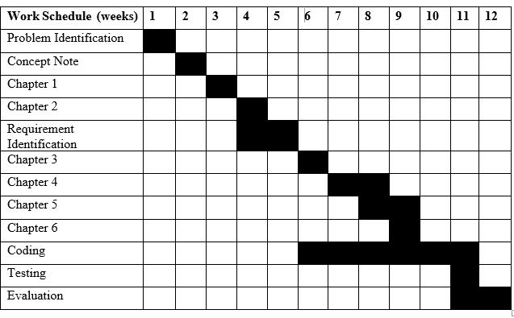

Appendix B: Registration Page

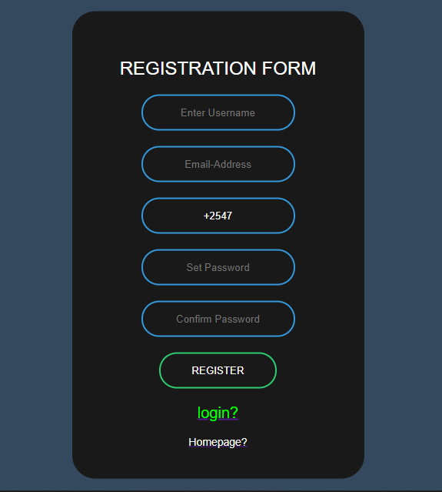

Appendix C: Login Page

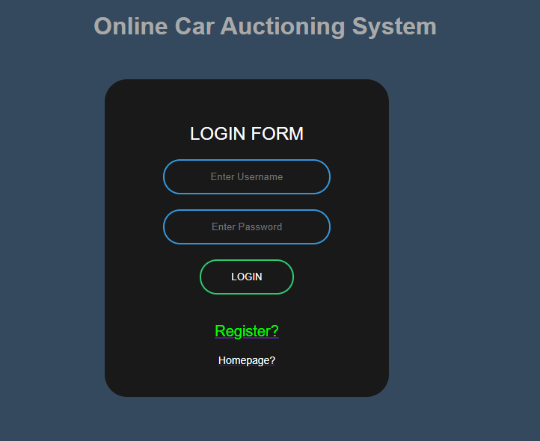

Appendix D: Home Page

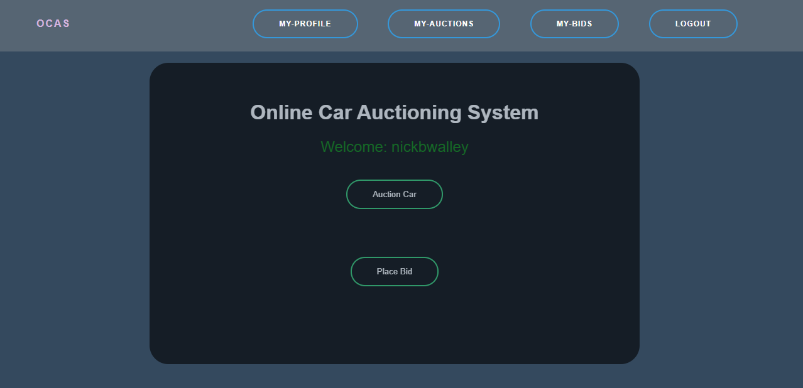

Appendix E: Auctions Page

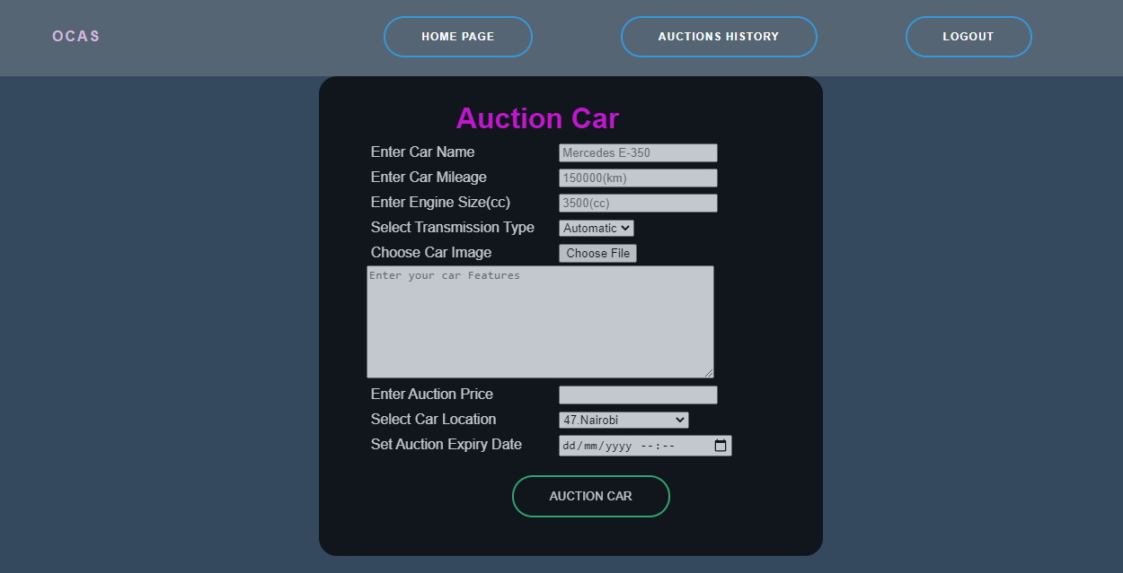

Appendix F: Bid Page

